Hessian Matrix
Definition: square matrix with order of n (number of the features or variables), its elements representing the second-order derivatives that measures local curvature (how sharply the curve it turns or deviate from a straight line at any given point)
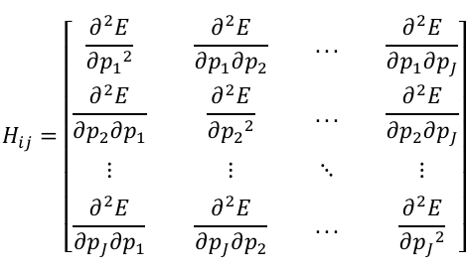
We may ask why it is important to obtain the second-order derivative, while we use the gradient (matrix of the first derivative) to show us how well our model performs by giving us an insight of points in the direction of steepest change to reduce the loss but gradient tells us only about the slope not the change of this slope , and to obtain the change of the changing slope (how the gradient evolves) we derive again resulting the second-order derivative (Hessian Matrix)
It helps analyze critical points, such as minima, maxima, and saddle points, and guides advanced numerical optimization techniques.

Specifically used in AI to optimize complex, high-dimensional loss landscapes.
Applications in ML:
- In neural networks, analyzing the Hessian can reveal the presence of saddle points and flat regions.
- In convex optimization problems, the Hessian helps verify convexity and guides second-order solvers.
- In fine-tuning models, knowledge of the Hessian helps adapt learning rates based on local curvature

